Chapter 5

# Try It Yourself: Select Distinct Values of Variables

## Excel Instructions

1. Open Customers.csv in Excel.
2. Save a copy called Customer-distinct countries.csv.
3. How many distinct countries are in the **Customers** table?
   1. Select the column whose header is Country, Column G.
   2. Go to the Excel ribbon at the top of your screen. Go to Data→Remove Duplicates.
   3. Keep the default option “Expand the selection” and click “Remove Duplicates…”
   4. Click the “Unselect All” button.
   5. Click the “Country” check box.

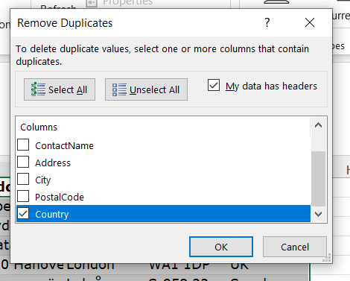

* 1. Click OK.
  2. You will get an information box that 70 duplicate values were found. Click OK.
  3. Select column G again. At the bottom of the screen, you will see “Count: 22.”



* 1. Since the first row has the “Countries” header, subtract 22 rows - 1 header row = 21 distinct countries.

1. Which of the following are countries that Zahava’s customers live in?
   1. Click on the header of Column G to select the entire column.
   2. Press Ctrl + F on your keyboard (or Cmd + F on a Mac). This will open the 'Find and Replace' dialog box.
   3. In the dialog box, enter the name of each country listed in Question 2 in the 'Find what' field. For example, enter “Argentina” under “Find what:” and click “Find All” to see if it appears in the table.